**Request for Proposal:** Columbus and the new trade route

By: Hai-Au Vo, Jonathan Chang, Sakura Kishiro, and Justin Chin.

**Executive Summary:**

The main purposes for this expedition to Asia are to bring back spices and other goods, to increase trade between Asia and Spain while finding a faster trade route, and to spread Christianity to other foreign lands. Spain would benefit from this expedition because it would be the 1st European country to discover this faster trade route and could demand exclusive rights to trade with the merchants with the finest quality goods and increase the wealth of Spain. By having these exclusive rights, we could sell to other European countries at a higher price. In addition, we could help spread Christianity at a faster rate because travel time between Europe and Asia would be quicker. The costs of this trip would come from paying members that would be operating the ship, food and supplies for voyages, ships and materials, insurance for the ships, and for workers that will be working in Spain for the duration of the voyage. In order to have a successful trip, we will ensure that our crewmembers have been adequately trained through screenings in the hiring process, as well as choosing ships with a good probability of successfully completing a 2 way voyage. We will also request monetary aid from your royal office to help us afford the various costs associated with this voyage. In addition, we plan to mitigate the various risks of this project by purchasing ships with high probabilities of completing the trip. We will purchase extra food so we don’t run out on sea, establish strong communication systems between ships through extensive training procedures before the trip, and bring back goods and people from Asia in order to prove the successful voyage and spread of Christianity. Overall, the duration of the trip should take 275 days and cost only about 3.7 million. It would be immensely beneficial for Spain to fund this project because of the potential benefits like increased trade, profit, and the expansion of Christianity in other foreign lands. These outweigh the costs of the project as a successful voyage will result in a substantial return on investment.

**Goals, Constraints, Assumptions:**

**Goals:**

* To discover a shorter and safer trade route to Asia by sea, especially to India
* To gain a first mover advantage on other European competitors and expand Spain’s empire and wealth
* To bring back gold, spices, and other luxury goods to increase Spain’s wealth
* To spread Christianity by evangelizing non-Christians who are encountered on the voyage

**Constraints**:

* Minimum wage laws mean that employees must be paid a certain amount
* Must purchase 3 boats
* Project can only start once initial royal funding is secured
* Hiring ads must be advertised for at least two weeks
* There are only 6 qualified boats for sale
* Each boat only has the cargo capacity and crew member capacity indicated on the chart
* food allotment ranges from 0.05kg to 0.08 kg per crewmember per day
* The three boats must sail close together to ensure effective communication
* Spain is in a recession and is concerned about costs

**Assumptions:**

* There are 30 days in a month
* We pay captains, navigators, and crewmembers as soon as they’re hired
* The crew size for each boat only accounts for the crewmembers
* Will buy a mix of barebones and hole foods items (half and half split buy crew number)
* Must purchase 3 different ships
* In the initial 2 week job ads, the positions for captain, navigator, and crewmember are all advertised -- three ads are bought for positions on the three ships
* The hiring process for navigators and crewmembers takes 2 weeks
* If a Shakedown cruise fails, it is assumed that only 1 boat failed (sunken or lost)
* During a failure, the other 2 boats return, so they do not fail
* They can only fail Shakedown twice before they terminate the project
* If a boat fails, we repurchase the same boat
* If the Shakedown fails, it means that the captains/navigators/crewmembers were not fit for the voyage or died, so we rehire them
* Each ship is equally likely to be lost during a failure -- so we can take an average to calculate expected cost
* We assume that insurance covers the repurchase cost of the failed boat
* If a shakedown fails, the duration of the tasks leading up to the shakedown stay the same length of time
* The expected duration of the shakedown cruise is 2.5 weeks (avg of 2 and 3 weeks)
* The duration of the repairs are on a beta distribution
* The duration of the voyage is distributed normally
* Life insurance will for captains will only be bought upon successfully completing shakedown cruise
* Some general assumptions:
  + Columbus and co. discount cash flows on a yearly basis -- because the project is not expected to take more than a year, there is no discounting
  + Additional cargo space (not taken up by food) can be used to store goods for trading and/or spoils acquired once in asia
  + Eating better food (hole foods) increases crew morale

**Project Plan and Proposed Schedule:**

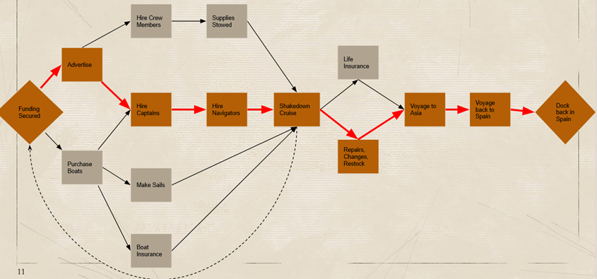

The first phase of drawing out the project plan is creating a precedence network. Starting with securing the initial funding for the project, three advertisements are put out for the staff, in this case the three captains needed for the three boats that are to be purchased. At the same time, the purchase of the three boats can take place. After two weeks of advertisements, the process of hiring the three captains, which is to take two weeks, will take place as well as the hiring of crew members which we assume will also take two weeks. Following the purchase of the three boats, the boat insurances, preparations of the sails, and the process of hiring the captains can start. Making the sails would take about four weeks and the boat insurance negotiations will take one week. Once the three captains are hired, they themselves will hire the navigators, a process that we assume will take the same amount of two weeks to hire. When all crew members are hired, supplies can also be stowed which we assume will take approximately 0.14 weeks to get delivered to the boats. Once supplies are stowed, navigators are hired, sails are made, and the boat insurance is purchased, the process of the shakedown cruise can start. There is a 95% chance of it taking only 2.5 weeks (an average of 2 and 3 weeks, an assumption we made) given that all boats pass the trial run. There is a (0.95*0.05) 4.75% chance of it taking 5 weeks given that at least one boat fails on the trial run the first time, having to go back to securing funding and starting the process again. Finally, there is a (0.05*0.05) 0.25% chance that it will take 7.5 weeks given that at least one boat fails two trial runs and makes it successfully on the third time around. A weighted average is taken (2.5*0.95 + 5*0.0475 + 7.5*0.0025) to give us an expected duration of roughly 2.6 weeks. Given that the shakedown cruise is a success, life insurance is then negotiated for the three captains, a process that will take one week, and repairs, changes to staff, and restock of inventory will then take place, a process that would take roughly 3.8 weeks. This number was calculated based off of the most likely duration of 3.5 weeks, the optimistic estimate of one week, and a pessimistic estimate of eight weeks. Variance (1.36), alpha (3.1), beta (4.6), and a random number is calculated to give us an expected duration for this task. A Monte Carlo simulation is then conducted for a total of 600 trials to get us the 3.8-week average duration. We are 95% confident that the duration of this task would fall between 3.7 weeks and 3.9 weeks. Once the repairs, changes, restock, and life insurance are figured out, the voyage to Asia can officially begin with a duration of 12 weeks. However, given there is a 65% chance it will take us less than 16 weeks to get to asia, using norm.s.inv(0.65) to find a Z score and entering the Z score into our formula ((16-12)/Z score), we are able to find the standard deviation to be 10.4. Given the standard deviation, we are 95% confident the duration of the voyage to asia can range anywhere from 0 weeks to 32.3 weeks. Once the boats have reached destination, they will begin their voyage back to Spain for another 12 weeks until they dock the boats back in Spain Once again. Using the same calculation as we did for the voyage to Asia but with a 75% chance this time, we get a standard deviation of 5.9, meaning we are 95% confident the duration of the journey back to spain is anywhere between 0.4 weeks to 23.6 weeks. Once we calculated the total slack from early start and late finish, we were able to figure out the critical path which consist of: secure funding, advertisement, hire captains, hire navigators, shakedown cruise, repairs, changes, and restock, voyage to Asia, voyage to Spain, and finally docking the boats back in Spain. Overall the project duration should be approximately 39.3 weeks or 275 days.

The GANTT chart provides a clearer picture of the tasks.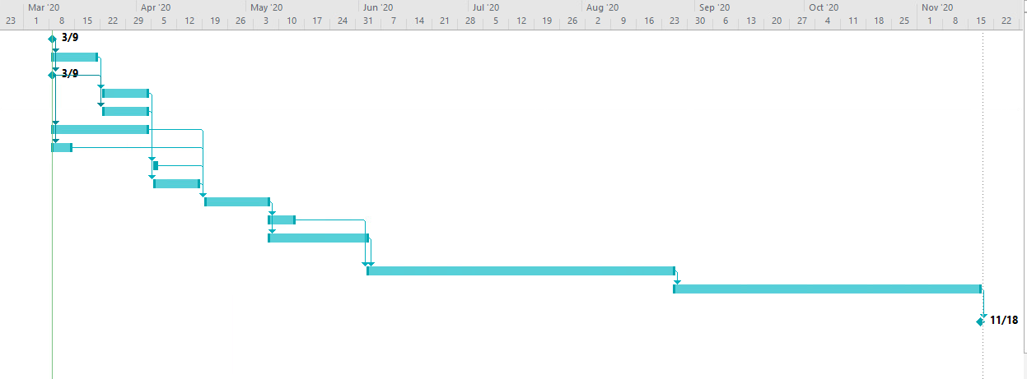

Finally, when creating the work breakdown structure, we broke down the tasks into 5 categories of: get boats ready for voyage, purchase needs, hire staff, conduct & adjust for shakedown, and voyage on new routes. Under the task of getting the boats ready for voyage, we broke it down even further into tasks such as purchase the three boats, make sails, stowed away supplies, and the purchase and negotiations of boat insurance. Under purchase needs, we broke the task down into purchase food, purchase of non-edible supplies, and purchase of navigation supplies. Under the broad task of hiring staff, we have mini tasks such as placing three advertisements, hiring captains, navigators, and crew members, and the purchase and negotiation of life insurance for captains. Under the task of conducting and adjusting for shakedown, we broke it down into repair of ship, adjustment in staffs, and restock of supplies. Lastly under voyage on new routes, we broke it down into sail to Asia, bring back spices, spread Christinaity, and sail back to spain. 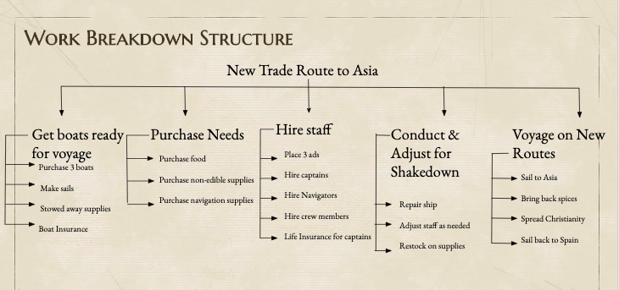

In terms of potentially using Agile project management, we believe that it is a relatively new, innovative way in which projects are handled, compared to the traditional way. It has many benefits, especially since it makes the project more flexible and allows for more changes to the scope and features. However, we do not believe that Agile is necessary for this particular project.

Some of the key features of Agile do not align with the features of this project. For example, Agile is useful for projects where it is difficult to define tasks, costs, and durations at the beginning. However, most of these were outlined in the case and we are able to calculate estimated costs and durations. Also, Agile could make the project duration longer which would also increase the total cost. This is a problem for the client because one of their main goals is to keep the project at a low cost and also to complete it as quickly as possible. In terms of Agile teams, this also does not work very well with this project. Agile teams are usually small (5-9) people and co-located, but teams on the ship have many more people. Another important aspect are brief daily ‘stand-up’ meetings, but this is not very possible during the voyage as the staff are split up between three ships. Additionally, the clients and the other staff like the comptroller, are stationed in Spain and would not be able to join any meetings since there was no video-calling technology during this time. Team members are also typically cross-functional and knowledgeable about all phases of the project. While this may be necessary for employees like the project manager and the ship captains, it is not necessary for employees like the navigator or the crew members.

Therefore, we do not believe that Agile project management is appropriate for this voyage. However, if it was implemented, this could look like each small task being broken into an individual sprint. For example, the task of advertising job openings could be its own sprint, spanning about 2 weeks and handled by the project manager, comptroller, and administrative assistant. This could allow features of the project to be changed more easily within the tasks.

**Terms of Contract:**

The proposed contract to the client includes aspects of a fixed price as well as a cost-plus contract. First of all, it is an incomplete contract because the contract cannot specify every single consequence of every possible state for this project. In some aspects, it is also a fixed price contract because the contractor needs a lump sum payment of about $686,757 at the beginning of the project to fund the pre-voyage costs. This price is based off of the expected duration of the project until the end of the shakedown cruise. This would include things like the purchase price of the boats, the sails, the hiring advertisements, food supplies, etc. It would also include the salaries to the ship captains, navigators, crewmembers, and other employees, based on their daily wage rate and the expected duration.

The project will receive another lump sum of $387,532.14 for the preparations for the final voyage, like restocking food and buying life insurance for the captains. This sum would be paid at t=65.6 days after the end of the shakedown cruise milestone.

The other part of the contract is for the actual voyage, and is similar to a cost plus contract. It is based off of the actual salary costs incurred during the voyage. The expected duration of the voyage is 182.5 days which means that they should be paid a sum of $2,620,047.60 after the milestone of the voyage is complete. However, to provide further incentive to return to Spain on time, there are bonuses of $5000 per day for returning earlier than the expected duration and penalties of $10000 per day for returning later than the expected duration. $1000 is a significant penalty because it will be very costly to Columbus to not receive this amount of money if they do not return on time, especially because daily salary costs to employees alone, exceed $12000. On the other hand, the bonus of $5000 per day should not be too costly to the King and Queen to pay extra for this project, if the voyage does end earlier than expected.

**Risk Management Plan:**

There are many risks associated with sailing in the 1400 and 1500s to find a new travel route to Asia. In particular, there are a few very important risks that we need to be wary of, like having boats capable of making the voyage, making sure there is enough food, making sure communication is possible ship to ship, and making sure that the crew doesn’t lie about completing the voyage to Asia. In order to mitigate these risks, we will incorporate certain actions like choosing the boats with at least an average of 80% probability of successfully completing the 2 way voyage. We chose 80% because we assume that the costs associated with lower percentages wouldn’t be worth it to have to start over again, as completing this trip on time is one of our main priorities. In addition, we will purchase extra food as well as a mix of bare-bones and hole foods in order to make sure we don’t run out of food during the voyage. If we ran out of food, it would mean the end of the voyage since the crew members would be too tired or even die of starvation. As for making sure communication is possible, we would have crewmembers use a horn on which they could send certain messages based on how many times they blew into it. In addition, before the trip starts and while in preparation for the voyage, they could train messenger pigeons in order to deliver messages back and forth for more complex communication.

As for the proof of a successful trip, we would bring back various spices indigenous to the Asian continent as well as bring back natives to convert to Christianity. By doing so, we can have these converts go back to their native land and further spread Christianity. This would make sure that the crew would not be able to lie about making a successful trip unless they actually reached Asia.

There are still many other risks associated with this project however, the most important are the ones addressed above. The other risks and their mitigation methods can be found in the table below.

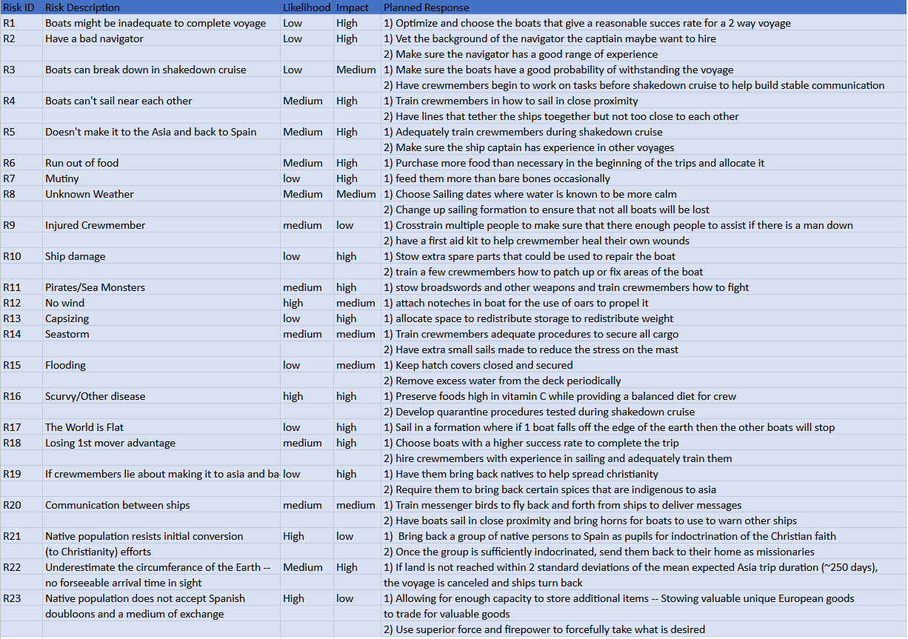

**Estimated Project Cost and Duration:**

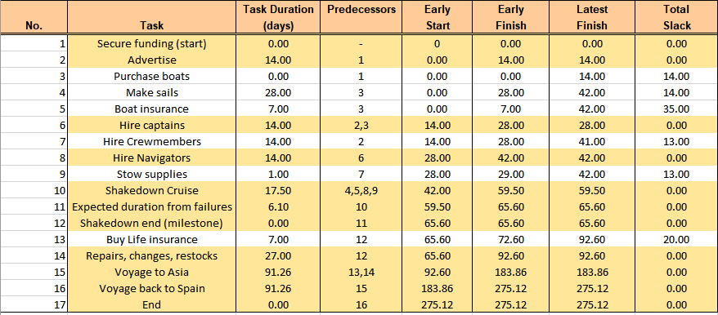

Project durations were found in accordance to the AON precedence network proposed in our project schedule. Tasks are described and cumulative durations are shown in the table above. The durations are calculated based on expected durations where the project can be split up into three main sections. First, is the expected duration of the project up until the shakedown result (milestone) -- this includes time added due to expected shakedown failures. Because probabilities are provided for likelihood of success (95%) and failure (5%) and we also assume that there can only be a maximum of two shakedown failures, we can calculate the weighted average expected duration for this portion of the project. The next segment of expected duration to be calculated are the repairs / restocks task (critical task) which we assumed lies on a beta distribution. For this task we ran a monte carlo simulation for the task and used the average of many trials for the duration. Lastly, the final segment are the two tasks representing the final voyage. Because both voyages lie on normal distributions and their mean durations are given, we can just use those.

Since extra probabilities and durations are given , we can also find the standard deviations of both distributions and 95% confidence level upper bound times for both the trips.

The voyage to Asia N~(91.26,78.95) with Upper bound duration of 246.00 days

The voyage back to Spain N~(91.26, 45.10) with Upper bound duration of 179.66 days

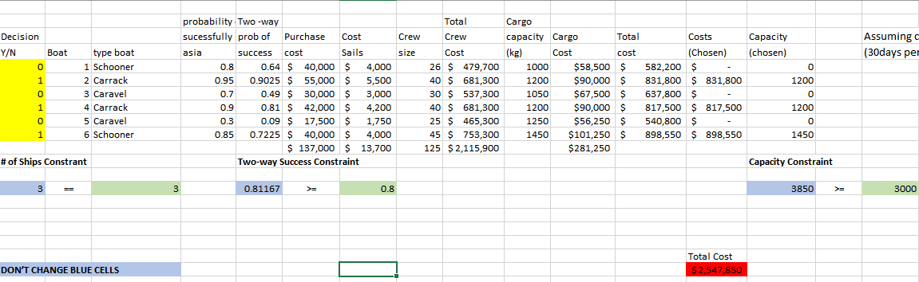

To find expected project cost, we first had to decide which ships to purchase. Subject to number of ship constraints, probability of voyage success, and minimum capacity constraints we ran a linear optimization solver model to choose our ships. Minimum capacity constraint of 3500 Our 80% two-way success became one of our binding constraints, and it turned out the only ships that could satisfy this constraint while minimizing cost were just the three ships with the highest probabilities of success(Carrack 2, Carrack 4, Schooner 6).

Expected costs for the rest of the project were split into three sections similar to how our project duration was divided -- 1) expected cost of project up to Shakedown result (milestone), 2) expected cost of final preparations for final voyage (restock of food, life insurance), 3)expected cost of salaries payable after the shakedown cruise and during final voyage

1. E[Cost] project up to shakedown result = $679,087.53

1. E[Cost] preparation for final voyage = $ 387,532.14

1. E[Cost] final voyage = $2,619,954.25

Total expected project cost is the sum of these three = $2,619,954.25

\***Please refer to additional excel file titled ‘columbusdurations’ for greater details**